**ALAT-ALAT LABORATORIUM PROTEKSI TANAMAN**

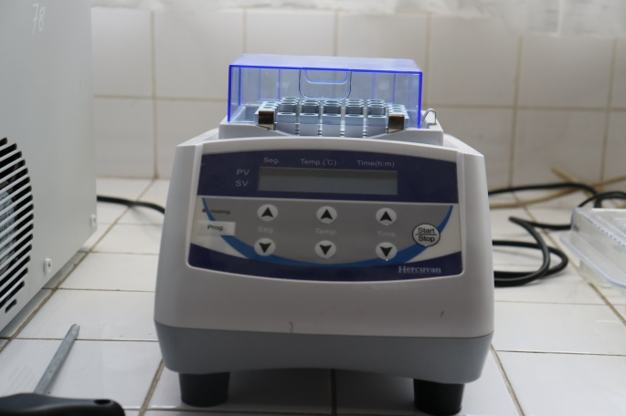 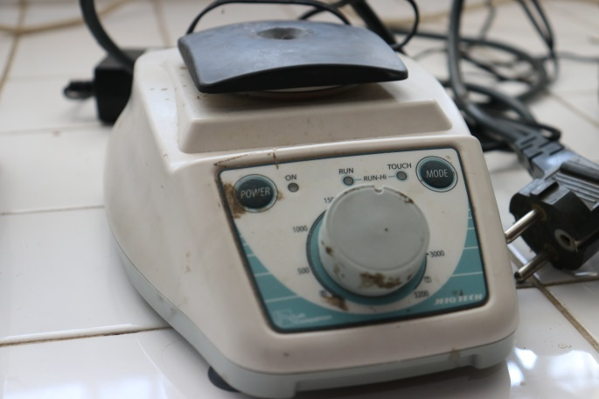 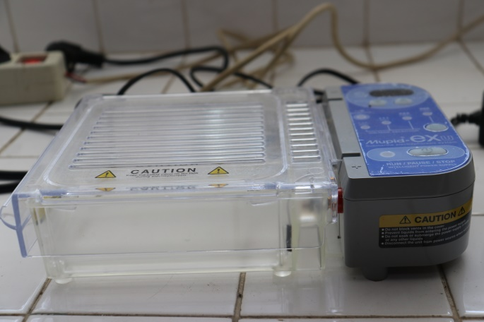 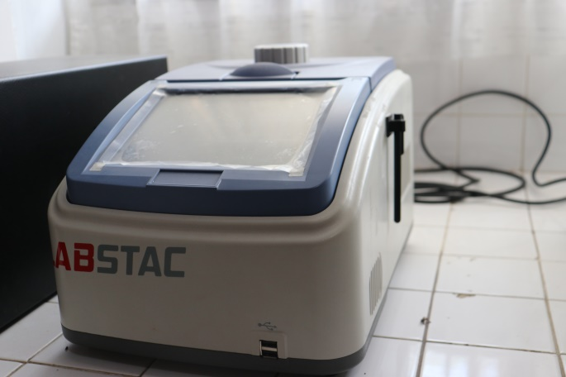 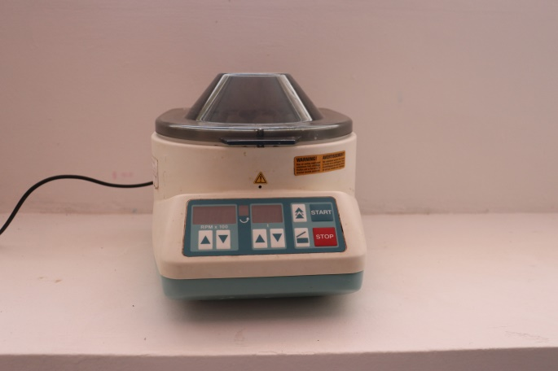 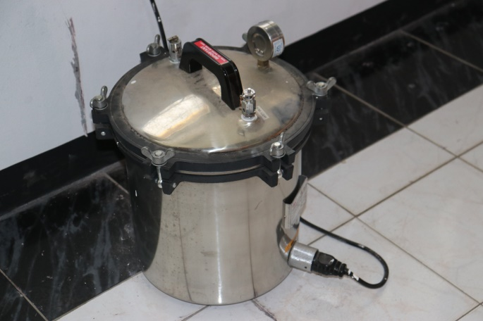 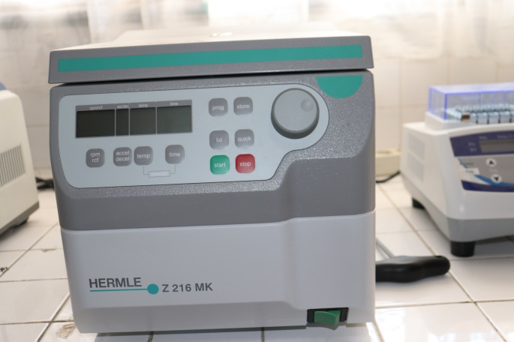 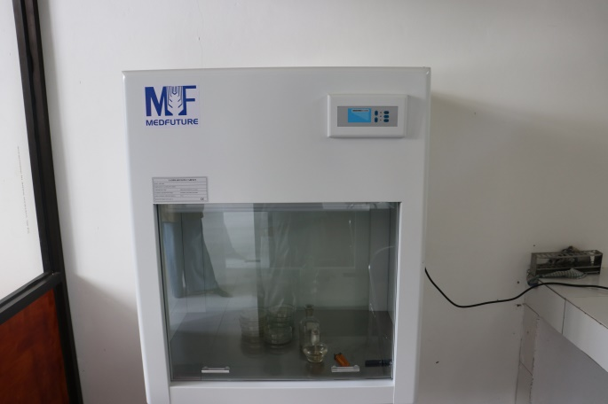 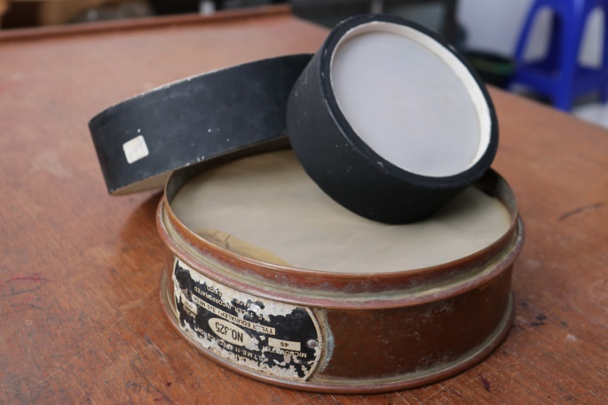 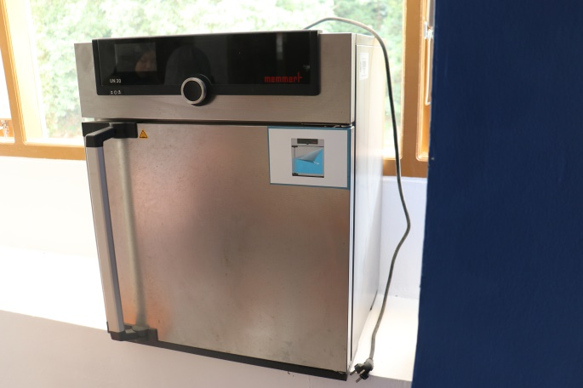 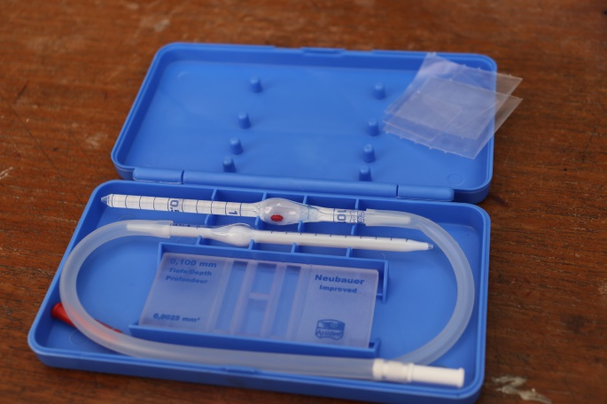 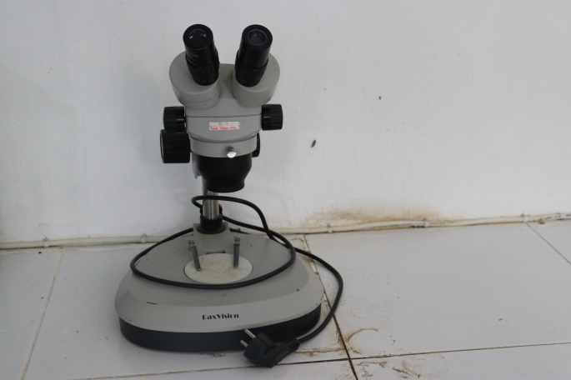

GRADIENT THERMAL CYCLER

DRY BATH INCUBATOR

VORTEX MIXER

ELECTROPHORESIS SYMSTEM

CENTRIFUGE (900 rpm)

AUTOCLAVE

CENTRIFUGE (13000 rpm)

LAMINAR AIR FLOW

SARINGAN BERTINGKAT NEMATODA

INKUBATOR

HAEMOCYTOMETER

MIKROSKOP STREO

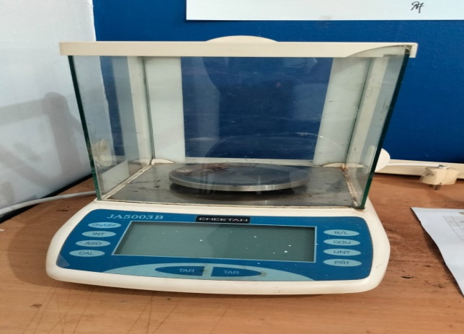

TIMBANGAN ANALITIK DIGITAL

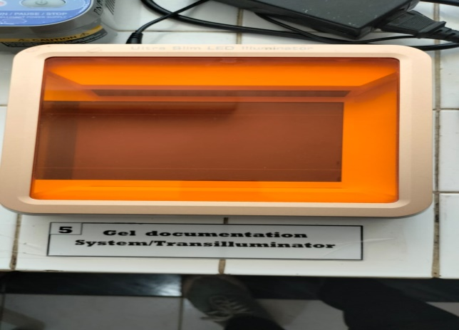

GEL DOCUMENTATION SYSTEM

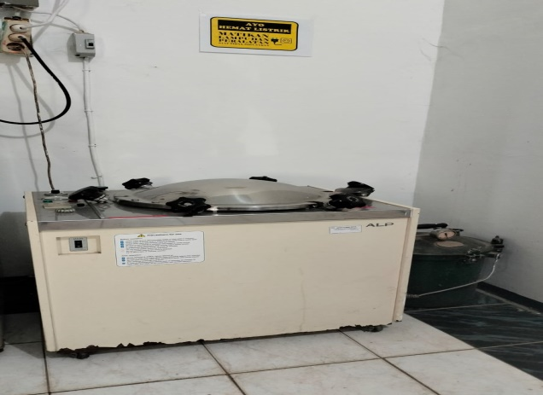

AUTOCLAVE

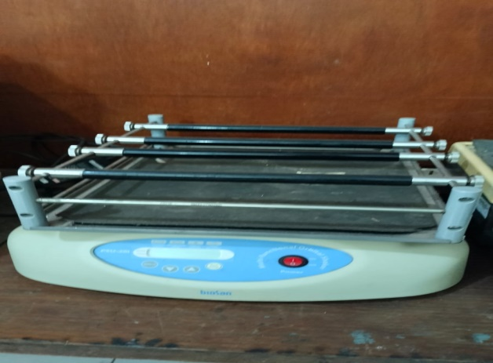

SHAKER

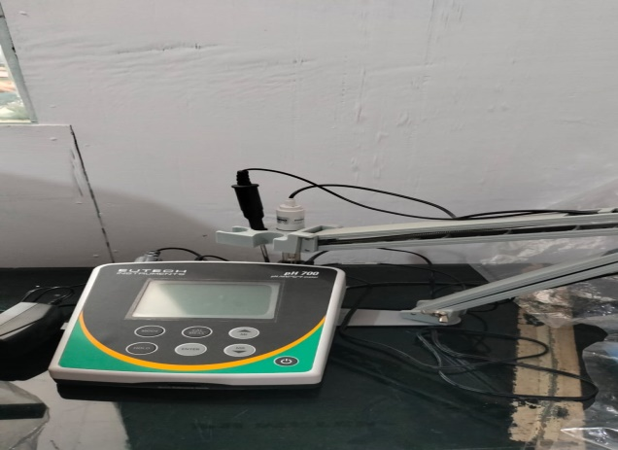

PH METER

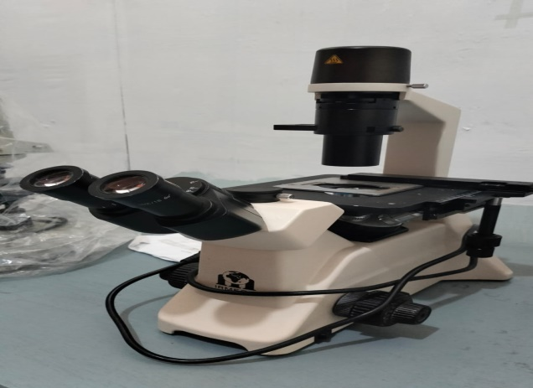

MIKROSKOP OKULER

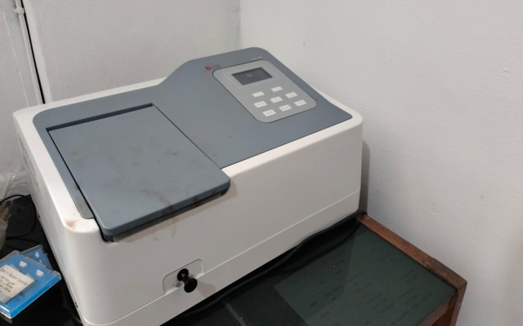

SPEKTROFOTOMETER

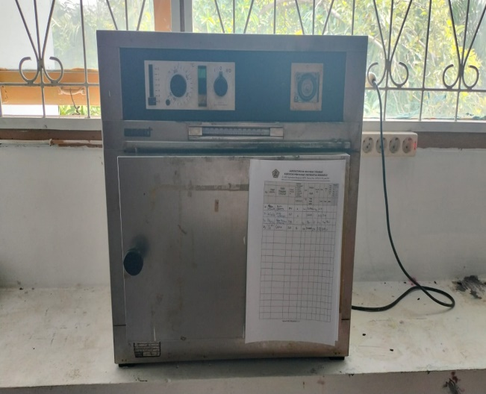

OVEN